1 #include<stdio.h>
#include<unistd.h>
#include<stdlib.h>
#include<fcntl.h>
#include<sys/stat.h>
#include<string.h>
int main(int argc, char *argv[])
{

int fd;
int i=0;
int k=0;
char buf[100][100];
char ch;
if(argc!=3)
{
printf("error\n");
exit(1);
}
fd=open(argv[2],O_RDONLY);
if(fd==-1)
{
printf("Cant open the file\n");
exit(1);
}
while((read(fd,&ch,1))==1)
{
if(ch!='\n')
{
buf[k][i]=ch;
i++;
}
else
{
buf[k][i]='\0';
if(strstr(buf[k],argv[1])!=NULL)
printf("line:%d %s\n",k+1,buf[k]);
i=0;
k++;
}
}
}

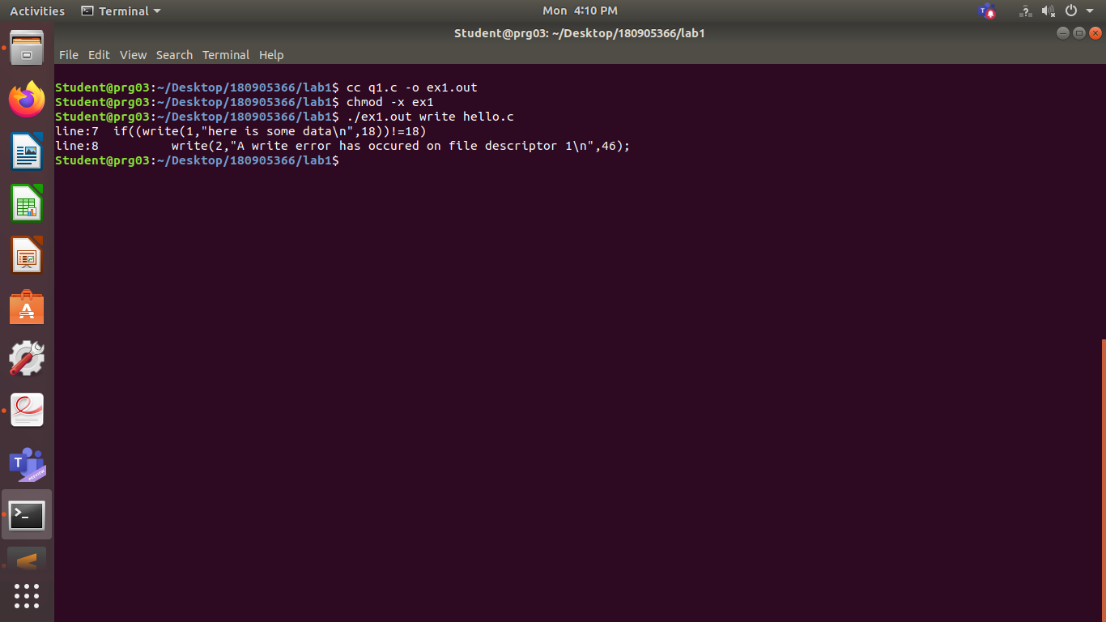

2

#include<stdio.h>
#include<unistd.h>
#include<stdlib.h>
#include<fcntl.h>
#include<sys/stat.h>
#include<string.h>
int main(int argc, char const *argv[])
{

int fd;
int k=0;
char buf[100][100];
char ch;
if(argc!=2)
{
printf("error\n");
exit(0);
}
fd=open(argv[1],O_RDONLY);
if(fd==-1)
{
printf("Cant open the file\n");
exit(0);
}
while(read(fd,&ch,1)==1)
{
if(ch=='\n')
{
k++;
}
printf("%c",ch);
if(k==20)
{
while((read(0,&ch,1))!=1);
k=0;
}
}
return 0;

}

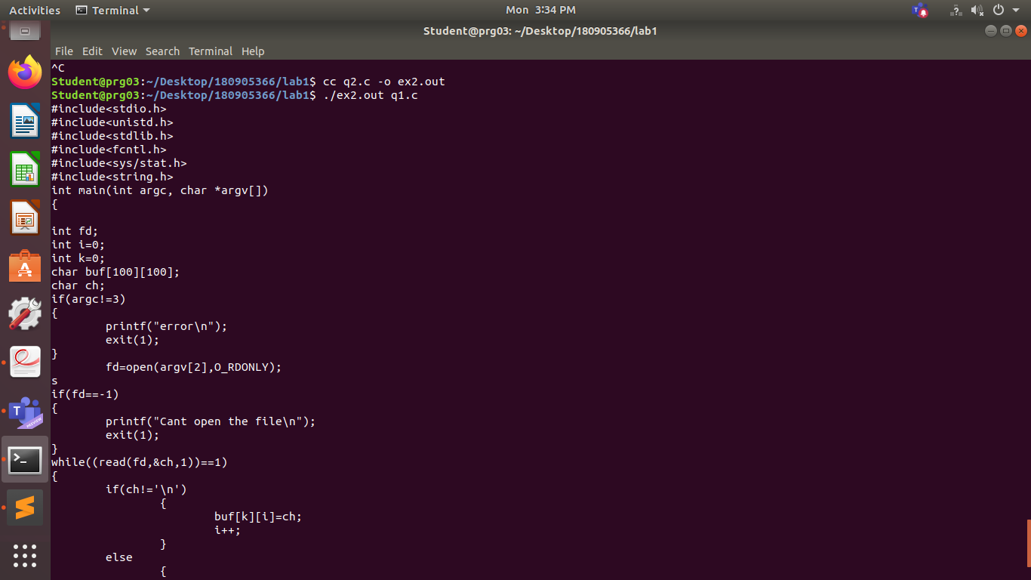

3

#include<stdio.h>
#include<unistd.h>
#include<stdlib.h>
#include<fcntl.h>
#include<sys/stat.h>
#include<string.h>
#include<errno.h>
int main(int argc, char const *argv[])
{ int i=-4;
unsigned int ui=54;
float f=3.14;
double d=1354.54654646;
char c='j';
char s[]="yash agarwal";
printf("\nInteger : %d",i);
printf("\nUnsigned Integer : %u",ui);
printf("\nFloat : %f",f);
printf("\nDouble : %lf",d);
printf("\nChar : %c", c);
printf("\nString : %s",s);
errno = EPERM;
printf("\nError NO. : %m\n");
return 0;
}

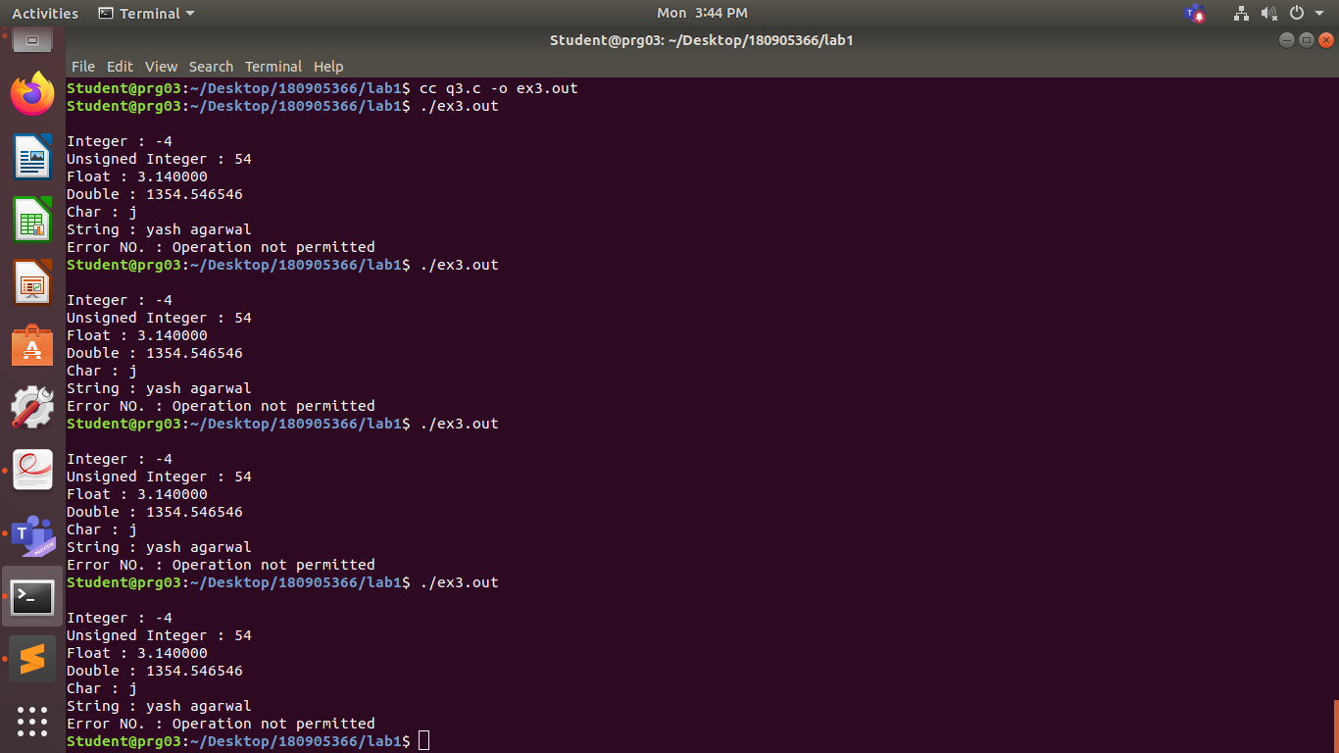

4

#include<stdio.h>
#include <stdlib.h>
int main(int argc, char const *argv[]){
FILE *in,*out;
in=(FILE*)fopen(argv[1],"r");
out=(FILE*)fopen(argv[2],"w");
if(in == NULL){
printf("Can't open the in");
exit(0);
}

if(out == NULL){
printf("Can't open the out");
exit(0);
}
int c=fgetc(in);
while(c!=EOF){
fputc(c,out);
c=fgetc(in);
}
fclose(in);
fclose(out);
return 0;
}
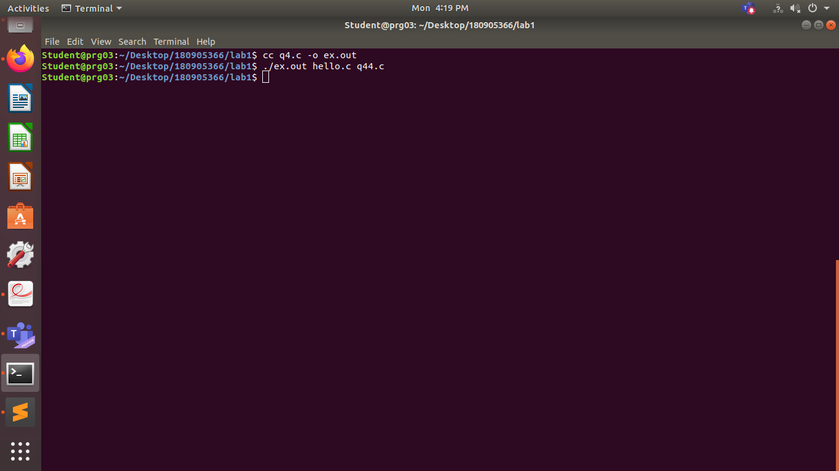

ex

#include<unistd.h>
#include<stdlib.h>
#include<fcntl.h>
#include<sys/stat.h>
int main()
{
if((write(1,"here is some data\n",18))!=18)
write(2,"A write error has occured on file descriptor 1\n",46);
char bu[128];
int nread;
nread=read(0,bu,128);
if(nread==-1)
write(2,"a read error has occured\n",26);
if((write(1,bu,nread))!=nread)
write(2,"a write error has occured\n",27);

char c;
int in,out;
in=open("hello.c",O_RDONLY);
out=open("file.out",O_WRONLY |O_CREAT,S_IRUSR |S_IWUSR);
while(read(in,&c,1)==1)
write(out,&c,1);
exit(0);
}
